MRAC 1 Plotting Results
- Changing only chaser mass from [400, 1100, 1800, 2500, 3200]
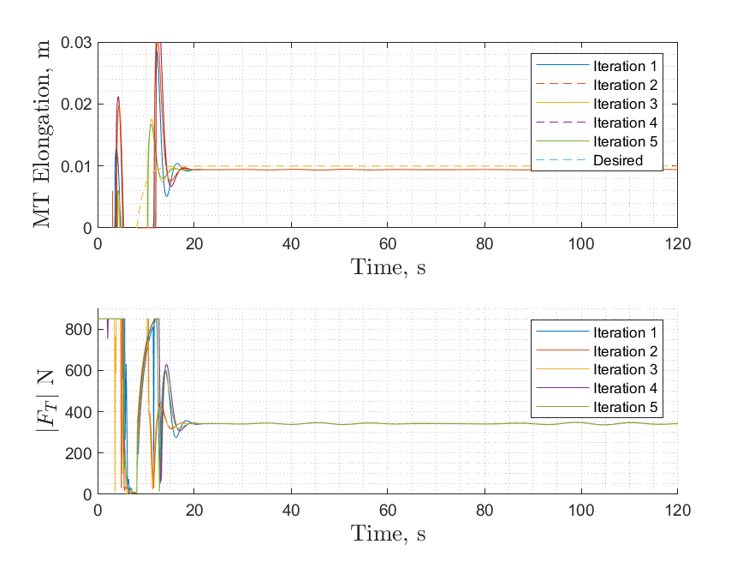
  - MT Elongation and Thrust Plot

Figure 1: MT Elongation with varying chaser mass
  - Adaptive Parameters Plot
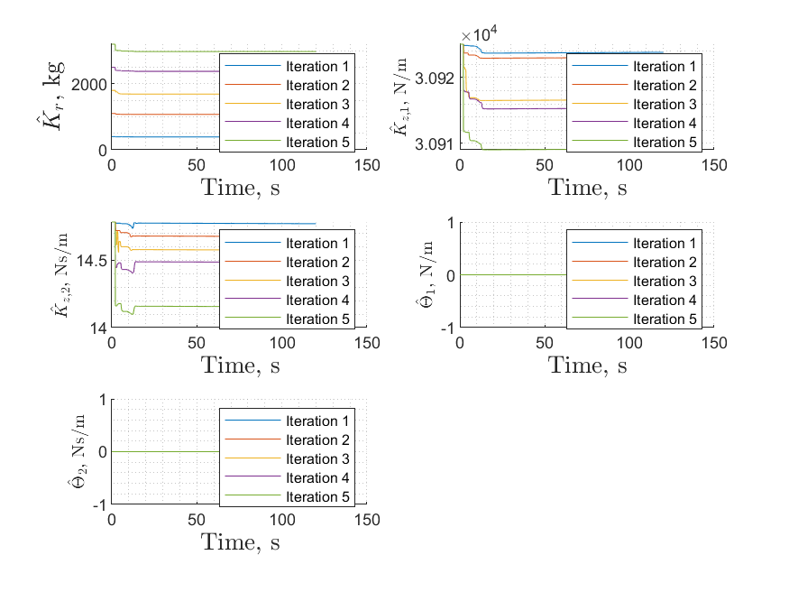

Figure 2: Adaptive Parameters with varying chaser mass
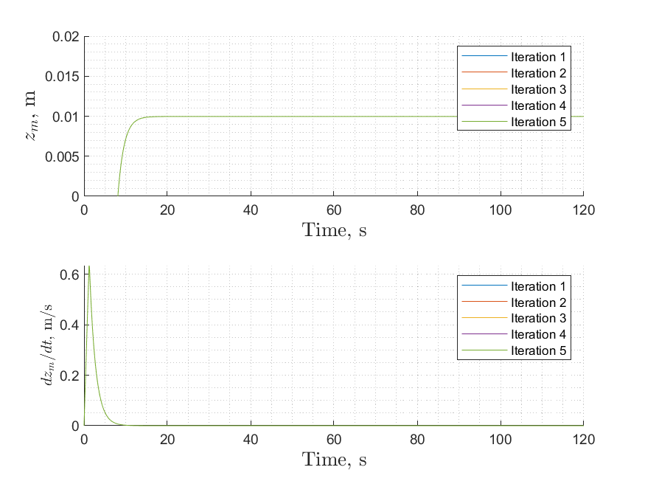
  - MT State Variables
Figure 3: Elongation State Variable with varying chaser mass

- Changing ${\hat{a}}_{1}$ adaptive parameter(Kvec) from [7731, 21261, 34791, 48320, 61850]
  - MT Elongation and Thrust Plot
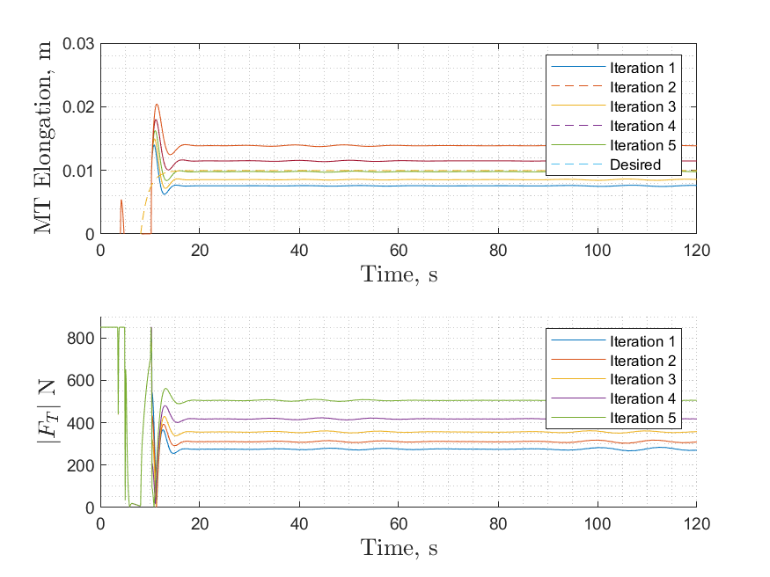

Figure 4: MT Elongation with varying ${\hat{a}}_{1}$
  - Adaptive Parameters Plot
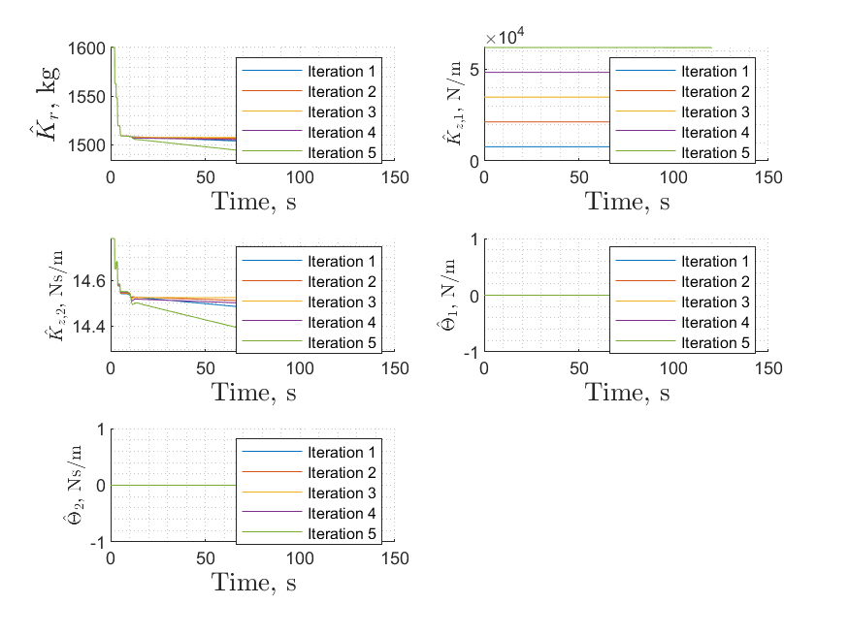
Figure 5 : Adaptive Parameters with varying ${\hat{a}}_{1}$
  - MT State Variables
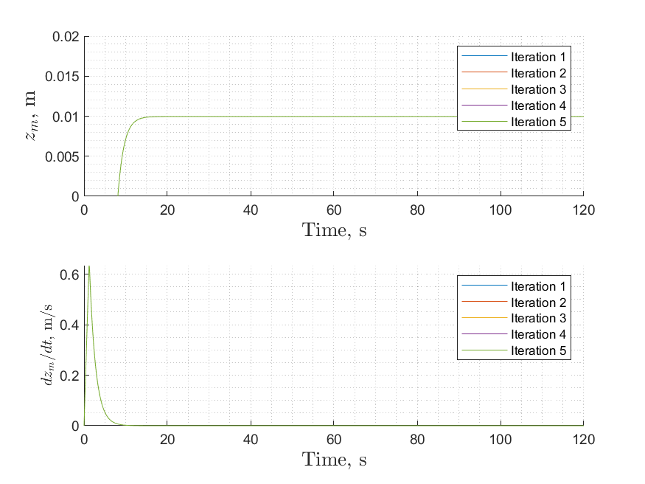
Figure 6: Elongation State Variable with varying ${\hat{a}}_{1}$

- Changing ${\hat{a}}_{2}$ adaptive parameter(Cvec) from [3.695, 10.162, 16.629, 23.096, 29.563]
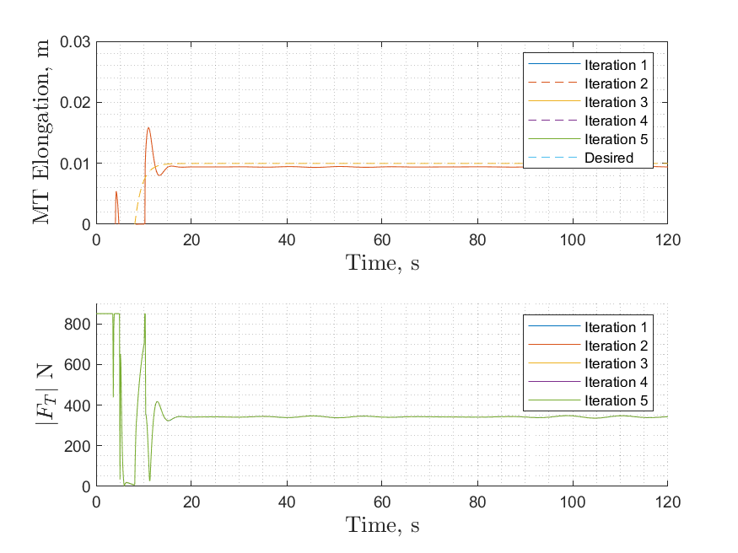
  - MT Elongation and Thrust Plot
Figure 7: MT Elongation with varying ${\hat{a}}_{2}$

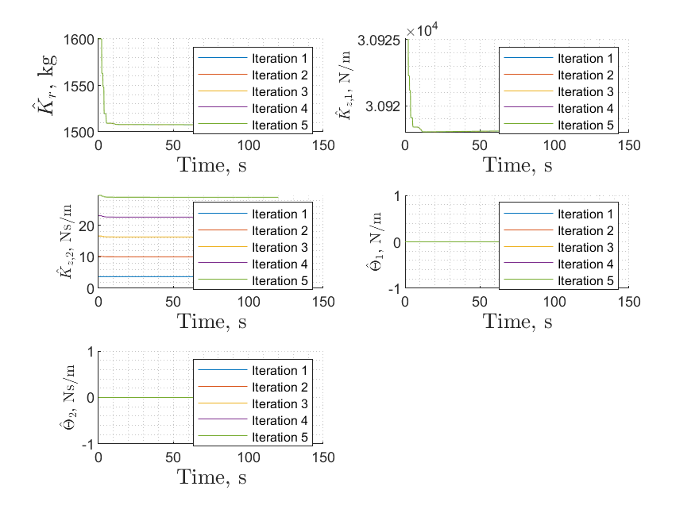
  - Adaptive Parameters Plot

Figure 8: Adaptive Parameters with varying ${\hat{a}}_{2}$

  - MT State Variables
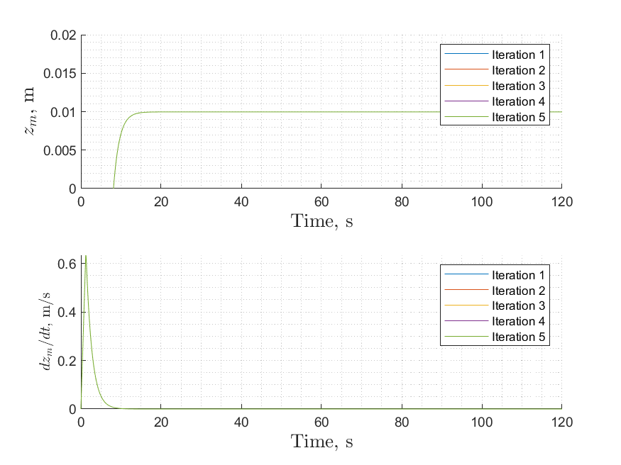
Figure 9: Elongation State Variable with varying ${\hat{a}}_{2}$
- Changing args.L0 parameter from [3.375, 9.281, 15.188, 21.094, 27]
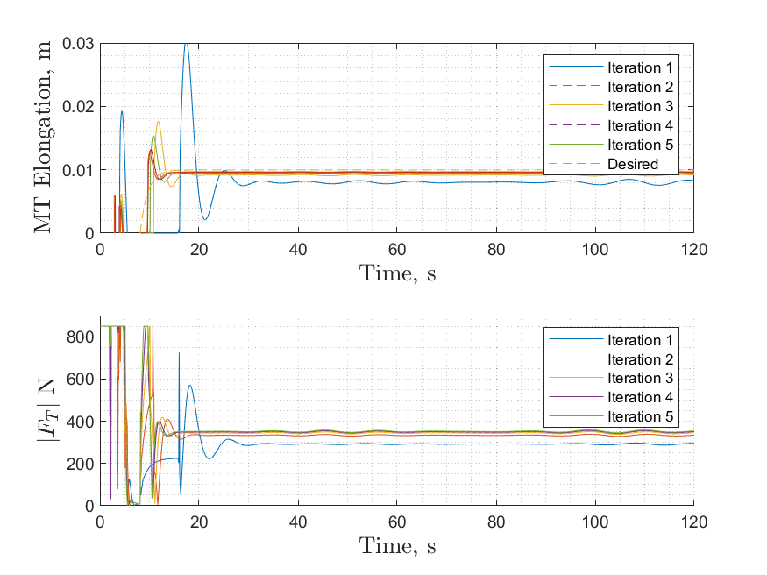
  - MT Elongation and Thrust Plot
Figure 10: MT Elongation with varying $L_{0}$

  - Adaptive Parameters Plot
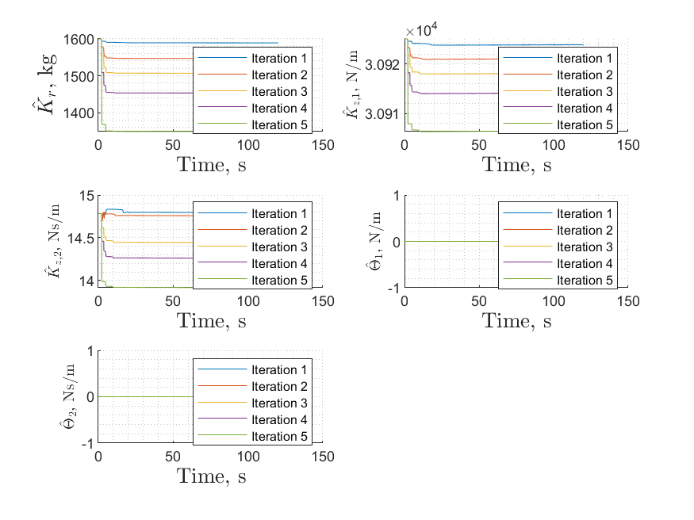
Figure 11: Adaptive Parameters with varying $L_{0}$
  - MT State Variables
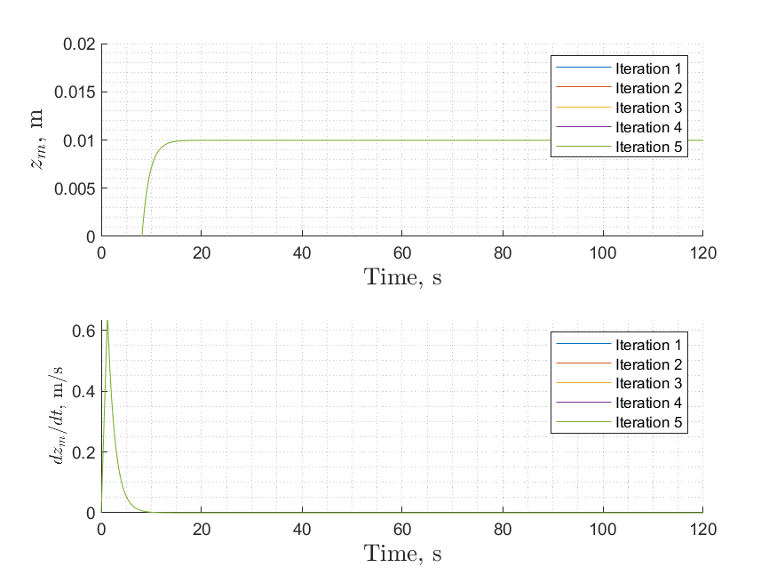
Figure 12: Elongation State Variable with varying $L_{0}$

- Changing args.kA parameter from [1672, 4598, 7524, 10450, 13376]
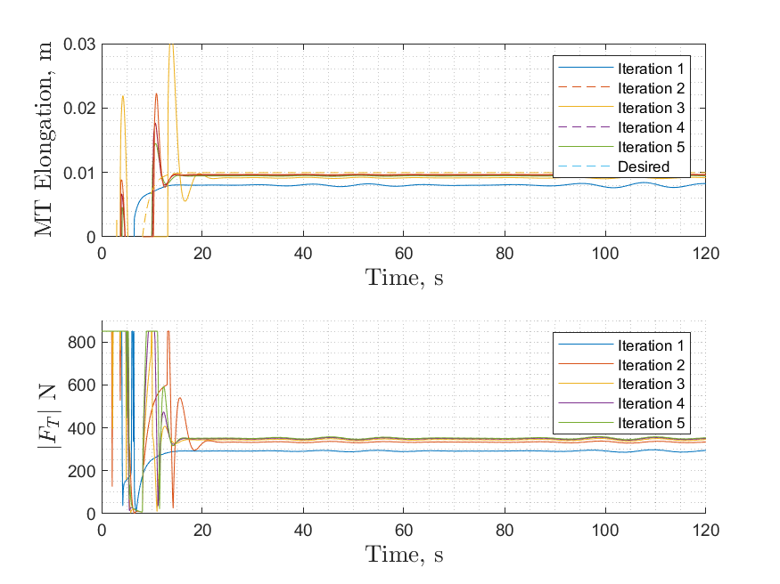
  - MT Elongation and Thrust Plot
Figure 13: MT Elongation with varying kA

  - Adaptive Parameters Plot
Figure 14: Adaptive Parameters with varying kA
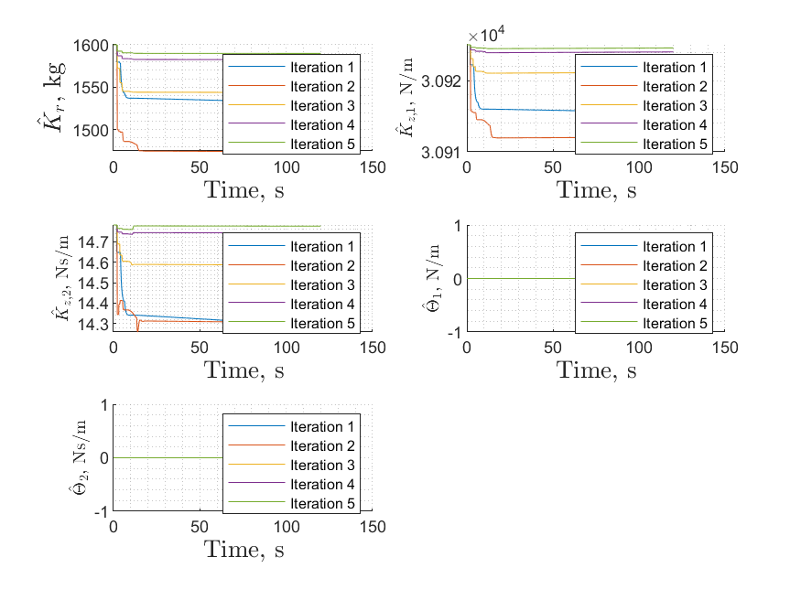

  - MT State Variables
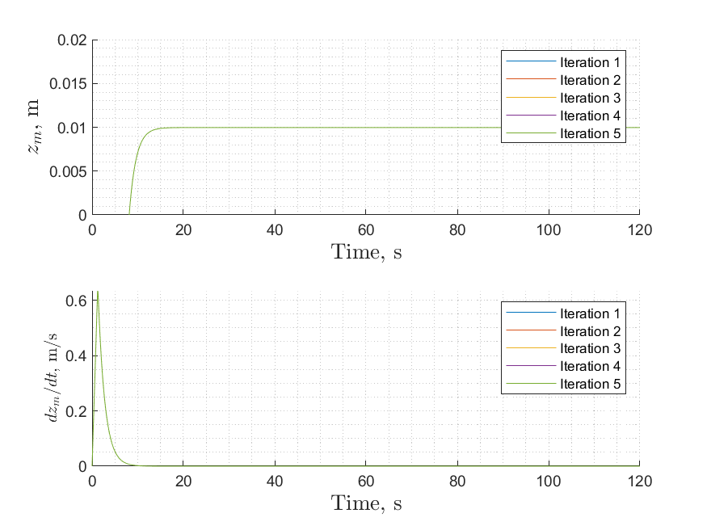
Figure 15: Elongation State Variable with varying kA

